LUCAS & EDDIE

Teacher Guide: Social-Emotional & Character Education

🌟 Program Overview
Lucas & Eddie is a story-based curriculum for ages 3–7 that builds emotional intelligence and moral reasoning through familiar characters, clear routines, and repeated language.
The program is divided into two complementary series:
🧠 Lucas & Eddie Learn About Feelings
⚖️ Lucas & Eddie Learn Right and Wrong
Together, they help children understand what they feel, why they feel it, and how to choose the right next step.

🎯 Program Goals (At a Glance)
- 🧠 Build emotional vocabulary
- ❤️ Develop empathy and self-regulation
- ⚖️ Strengthen moral decision-making
- 🏫 Support positive classroom culture
- 🏠 Reinforce learning at home

📘 How to Use This Guide
Each weekly lesson includes:
📖 Story Focus
💬 Guided Discussion
🎨 Hands-On Activity
🏠 Home Connection
✅ Observable Outcome
⏱️ Time: 20–30 minutes per lesson
👥 Format: Whole group, small group, SEL block, or literacy integration

🧠 SERIES 1

Lucas & Eddie Learn About Feelings
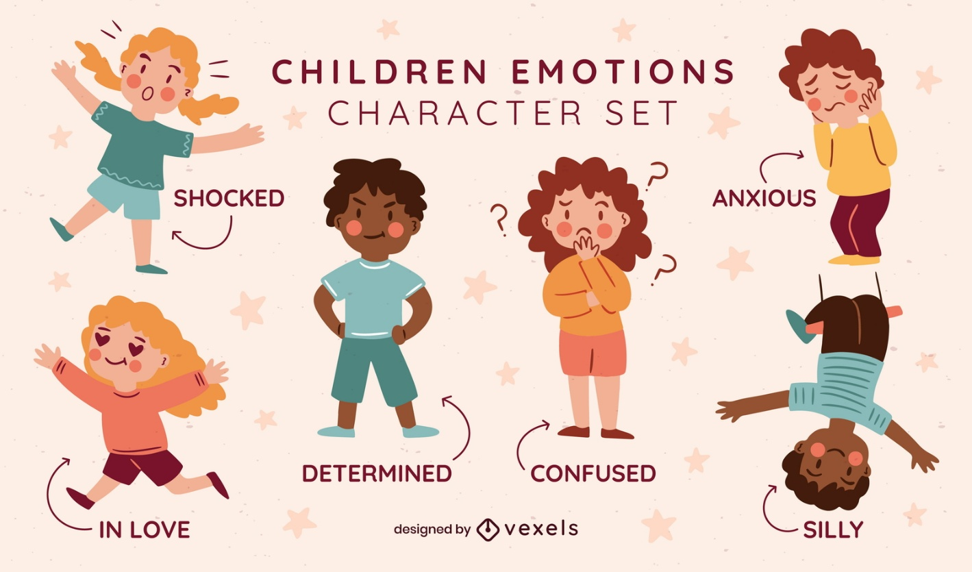
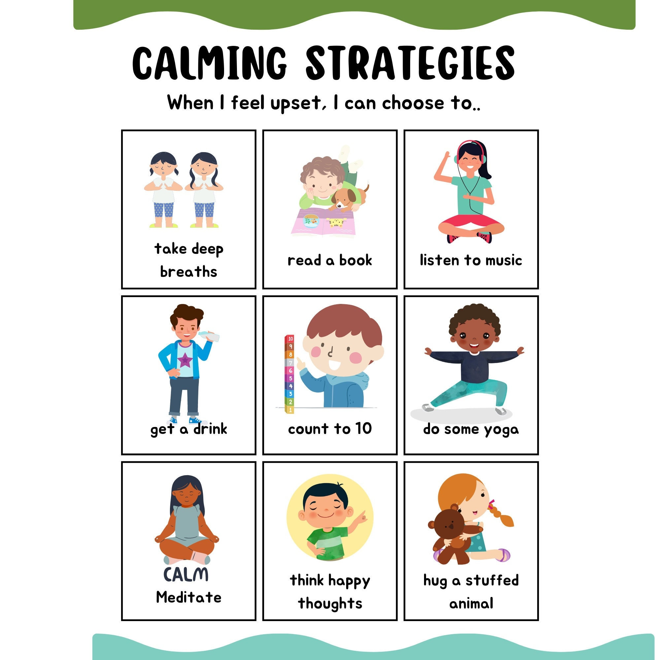
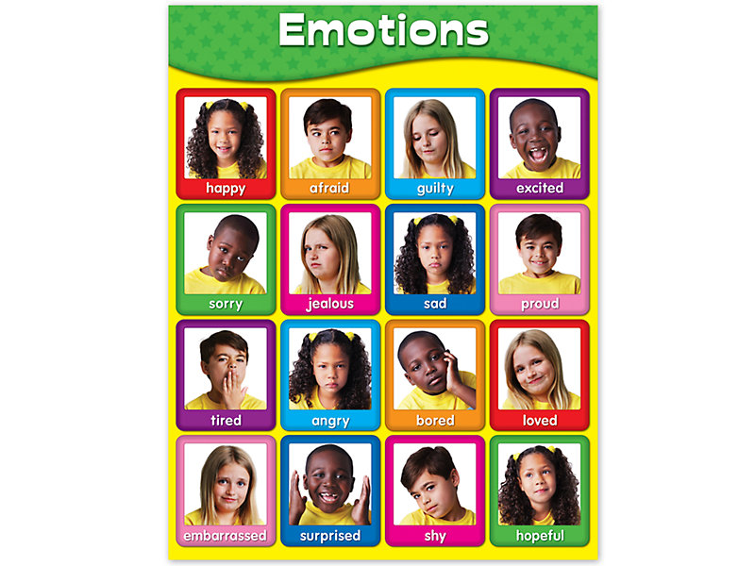
4
Focus: Emotional awareness, regulation, and empathy
Big Question: What is happening inside me?

📅 Scope & Sequence – Feelings
Week | Emotion | Skill Focus | Visual Cue
1 | Frustration | Body signals | 😤
2 | Anger | Feeling vs. behavior | 🔥
3 | Sadness | Seeking comfort | 😢
4 | Worry | Reassurance strategies | 🌧️
5 | Jealousy | Naming hard feelings | 👀
6 | Pride | Effort awareness | 🌟
7 | Gratitude | Appreciation | 🙏
8 | Empathy | Perspective-taking | ❤️

🧩 Weekly Lesson Layout (Feelings)
🟦 Story Connection
Eddie experiences a big feeling. Lucas helps him slow down, name it, and reset.
🟨 Classroom Activities
- Feelings chart check-in
- Body signal identification
- Breathing or movement reset
🟩 Home Connection
- “What feeling did you notice today?”
- Parent modeling language prompt
🟪 Performance Task
- Drawing or verbal reflection
- Emotion strategy poster or badge

⚖️ SERIES 2

Lucas & Eddie Learn Right and Wrong
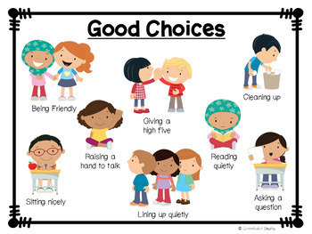

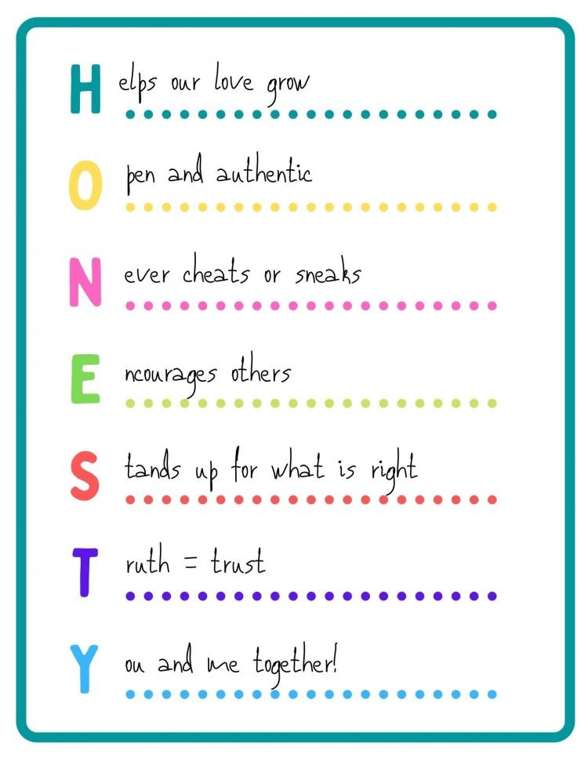
4
Focus: Moral reasoning and ethical behavior
Big Question: What is the right thing to do?

📅 Scope & Sequence – Right & Wrong
Week | Moral Focus | Skill Focus | Visual Cue
9 | Honesty | Truth-telling | 🗣️
10 | Fairness | Turn-taking | ⚖️
11 | Responsibility | Accountability | 🎒
12 | Inclusion | Belonging | 🤝
13 | Courage | Admitting mistakes | 🛡️
14 | Justice | Fair rules | 📜
15 | Perseverance | Not giving up | ⛰️
16 | Reflection | Growth awareness | 🎉

🧩 Weekly Lesson Layout (Right & Wrong)
🟦 Story Connection
Eddie faces a choice. Lucas models the right action and explains why it matters.
🟨 Classroom Activities
- Role-play scenarios
- “What should Eddie do?” discussions
- Choice → Outcome activities
🟩 Home Connection
- Family discussion prompt
- Simple real-life practice challenge
🟪 Performance Task
- Certificate, poster, or journal page

🏠 Family & Home Connections
🏠 Weekly prompts encourage:
- Shared language
- Modeling by adults
- Reinforcement without lectures
Examples:
- “What helped Eddie calm down?”
- “When did you make a fair choice today?”

📊 Assessment & Observation
✔ Teacher observation
✔ Student drawings and explanations
✔ Participation in discussion and role-play
No testing. No checklists from a bunker somewhere. Just real evidence of growth.

🏆 Culminating Celebration (Week 16)
🎉 Reflection Circle
📖 Student sharing
📜 Certificates of Growth
👨‍👩‍👧 Family participation encouraged

Lucas & Eddie – Weekly Lesson Cards (Aligned to Teacher Guide)

Week 1

🧠 Learn About Feelings

Lucas & Eddie Learn About Frustration
🎯 Focus: Frustration
🧠 Big Question: What is happening inside me?
🟦 Story Connection
Read the story aloud. Eddie experiences a situation connected to this week’s focus. Lucas helps him slow down, name what is happening, and decide on a next step.
🟨 Classroom Activities
• Guided discussion using the story
• Hands-on activity connected to the focus
• Movement, drawing, or role-play
🟩 Home Connection
• Simple family discussion prompt
• Adult modeling of language and behavior
🟪 Performance Task
• Student drawing, explanation, or reflection demonstrating understanding

Week 2

🧠 Learn About Feelings

Lucas & Eddie Learn About Anger
🎯 Focus: Anger
🧠 Big Question: What is happening inside me?
🟦 Story Connection
Read the story aloud. Eddie experiences a situation connected to this week’s focus. Lucas helps him slow down, name what is happening, and decide on a next step.
🟨 Classroom Activities
• Guided discussion using the story
• Hands-on activity connected to the focus
• Movement, drawing, or role-play
🟩 Home Connection
• Simple family discussion prompt
• Adult modeling of language and behavior
🟪 Performance Task
• Student drawing, explanation, or reflection demonstrating understanding

Week 3

🧠 Learn About Feelings

Lucas & Eddie Learn About Sadness
🎯 Focus: Sadness
🧠 Big Question: What is happening inside me?
🟦 Story Connection
Read the story aloud. Eddie experiences a situation connected to this week’s focus. Lucas helps him slow down, name what is happening, and decide on a next step.
🟨 Classroom Activities
• Guided discussion using the story
• Hands-on activity connected to the focus
• Movement, drawing, or role-play
🟩 Home Connection
• Simple family discussion prompt
• Adult modeling of language and behavior
🟪 Performance Task
• Student drawing, explanation, or reflection demonstrating understanding

Week 4

🧠 Learn About Feelings

Lucas & Eddie Learn About Worry
🎯 Focus: Worry
🧠 Big Question: What is happening inside me?
🟦 Story Connection
Read the story aloud. Eddie experiences a situation connected to this week’s focus. Lucas helps him slow down, name what is happening, and decide on a next step.
🟨 Classroom Activities
• Guided discussion using the story
• Hands-on activity connected to the focus
• Movement, drawing, or role-play
🟩 Home Connection
• Simple family discussion prompt
• Adult modeling of language and behavior
🟪 Performance Task
• Student drawing, explanation, or reflection demonstrating understanding

Week 5

🧠 Learn About Feelings

Lucas & Eddie Learn About Jealousy
🎯 Focus: Jealousy
🧠 Big Question: What is happening inside me?
🟦 Story Connection
Read the story aloud. Eddie experiences a situation connected to this week’s focus. Lucas helps him slow down, name what is happening, and decide on a next step.
🟨 Classroom Activities
• Guided discussion using the story
• Hands-on activity connected to the focus
• Movement, drawing, or role-play
🟩 Home Connection
• Simple family discussion prompt
• Adult modeling of language and behavior
🟪 Performance Task
• Student drawing, explanation, or reflection demonstrating understanding

Week 6

🧠 Learn About Feelings

Lucas & Eddie Learn About Pride
🎯 Focus: Pride
🧠 Big Question: What is happening inside me?
🟦 Story Connection
Read the story aloud. Eddie experiences a situation connected to this week’s focus. Lucas helps him slow down, name what is happening, and decide on a next step.
🟨 Classroom Activities
• Guided discussion using the story
• Hands-on activity connected to the focus
• Movement, drawing, or role-play
🟩 Home Connection
• Simple family discussion prompt
• Adult modeling of language and behavior
🟪 Performance Task
• Student drawing, explanation, or reflection demonstrating understanding

Week 7

🧠 Learn About Feelings

Lucas & Eddie Learn About Gratitude
🎯 Focus: Gratitude
🧠 Big Question: What is happening inside me?
🟦 Story Connection
Read the story aloud. Eddie experiences a situation connected to this week’s focus. Lucas helps him slow down, name what is happening, and decide on a next step.
🟨 Classroom Activities
• Guided discussion using the story
• Hands-on activity connected to the focus
• Movement, drawing, or role-play
🟩 Home Connection
• Simple family discussion prompt
• Adult modeling of language and behavior
🟪 Performance Task
• Student drawing, explanation, or reflection demonstrating understanding

Week 8

🧠 Learn About Feelings

Lucas & Eddie Learn About Empathy
🎯 Focus: Empathy
🧠 Big Question: What is happening inside me?
🟦 Story Connection
Read the story aloud. Eddie experiences a situation connected to this week’s focus. Lucas helps him slow down, name what is happening, and decide on a next step.
🟨 Classroom Activities
• Guided discussion using the story
• Hands-on activity connected to the focus
• Movement, drawing, or role-play
🟩 Home Connection
• Simple family discussion prompt
• Adult modeling of language and behavior
🟪 Performance Task
• Student drawing, explanation, or reflection demonstrating understanding

Week 9

⚖️ Learn Right and Wrong

Lucas & Eddie Learn About Honesty
🎯 Focus: Honesty
🧠 Big Question: What is the right thing to do?
🟦 Story Connection
Read the story aloud. Eddie experiences a situation connected to this week’s focus. Lucas helps him slow down, name what is happening, and decide on a next step.
🟨 Classroom Activities
• Guided discussion using the story
• Hands-on activity connected to the focus
• Movement, drawing, or role-play
🟩 Home Connection
• Simple family discussion prompt
• Adult modeling of language and behavior
🟪 Performance Task
• Student drawing, explanation, or reflection demonstrating understanding

Week 10

⚖️ Learn Right and Wrong

Lucas & Eddie Learn About Fairness
🎯 Focus: Fairness
🧠 Big Question: What is the right thing to do?
🟦 Story Connection
Read the story aloud. Eddie experiences a situation connected to this week’s focus. Lucas helps him slow down, name what is happening, and decide on a next step.
🟨 Classroom Activities
• Guided discussion using the story
• Hands-on activity connected to the focus
• Movement, drawing, or role-play
🟩 Home Connection
• Simple family discussion prompt
• Adult modeling of language and behavior
🟪 Performance Task
• Student drawing, explanation, or reflection demonstrating understanding

Week 11

⚖️ Learn Right and Wrong

Lucas & Eddie Learn About Responsibility
🎯 Focus: Responsibility
🧠 Big Question: What is the right thing to do?
🟦 Story Connection
Read the story aloud. Eddie experiences a situation connected to this week’s focus. Lucas helps him slow down, name what is happening, and decide on a next step.
🟨 Classroom Activities
• Guided discussion using the story
• Hands-on activity connected to the focus
• Movement, drawing, or role-play
🟩 Home Connection
• Simple family discussion prompt
• Adult modeling of language and behavior
🟪 Performance Task
• Student drawing, explanation, or reflection demonstrating understanding

Week 12

⚖️ Learn Right and Wrong

Lucas & Eddie Learn About Inclusion
🎯 Focus: Inclusion
🧠 Big Question: What is the right thing to do?
🟦 Story Connection
Read the story aloud. Eddie experiences a situation connected to this week’s focus. Lucas helps him slow down, name what is happening, and decide on a next step.
🟨 Classroom Activities
• Guided discussion using the story
• Hands-on activity connected to the focus
• Movement, drawing, or role-play
🟩 Home Connection
• Simple family discussion prompt
• Adult modeling of language and behavior
🟪 Performance Task
• Student drawing, explanation, or reflection demonstrating understanding

Week 13

⚖️ Learn Right and Wrong

Lucas & Eddie Learn About Courage
🎯 Focus: Courage
🧠 Big Question: What is the right thing to do?
🟦 Story Connection
Read the story aloud. Eddie experiences a situation connected to this week’s focus. Lucas helps him slow down, name what is happening, and decide on a next step.
🟨 Classroom Activities
• Guided discussion using the story
• Hands-on activity connected to the focus
• Movement, drawing, or role-play
🟩 Home Connection
• Simple family discussion prompt
• Adult modeling of language and behavior
🟪 Performance Task
• Student drawing, explanation, or reflection demonstrating understanding

Week 14

⚖️ Learn Right and Wrong

Lucas & Eddie Learn About Justice
🎯 Focus: Justice
🧠 Big Question: What is the right thing to do?
🟦 Story Connection
Read the story aloud. Eddie experiences a situation connected to this week’s focus. Lucas helps him slow down, name what is happening, and decide on a next step.
🟨 Classroom Activities
• Guided discussion using the story
• Hands-on activity connected to the focus
• Movement, drawing, or role-play
🟩 Home Connection
• Simple family discussion prompt
• Adult modeling of language and behavior
🟪 Performance Task
• Student drawing, explanation, or reflection demonstrating understanding

Week 15

⚖️ Learn Right and Wrong

Lucas & Eddie Learn About Perseverance
🎯 Focus: Perseverance
🧠 Big Question: What is the right thing to do?
🟦 Story Connection
Read the story aloud. Eddie experiences a situation connected to this week’s focus. Lucas helps him slow down, name what is happening, and decide on a next step.
🟨 Classroom Activities
• Guided discussion using the story
• Hands-on activity connected to the focus
• Movement, drawing, or role-play
🟩 Home Connection
• Simple family discussion prompt
• Adult modeling of language and behavior
🟪 Performance Task
• Student drawing, explanation, or reflection demonstrating understanding

Week 16

⭐ Reflection

Lucas & Eddie Reflect on What They Learned
🎯 Focus: Reflection
🧠 Big Question: What did I learn about myself?
🟦 Story Connection
Read the story aloud. Eddie experiences a situation connected to this week’s focus. Lucas helps him slow down, name what is happening, and decide on a next step.
🟨 Classroom Activities
• Guided discussion using the story
• Hands-on activity connected to the focus
• Movement, drawing, or role-play
🟩 Home Connection
• Simple family discussion prompt
• Adult modeling of language and behavior
🟪 Performance Task
• Student drawing, explanation, or reflection demonstrating understanding

